Mockito Hands-On Exercises

**Exercise 1: Mocking and Stubbing**

**Scenario:** You need to test a service that depends on an external API. Use Mockito to mock the external API and stub its methods.

**CODE:**

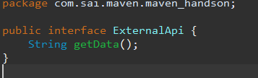

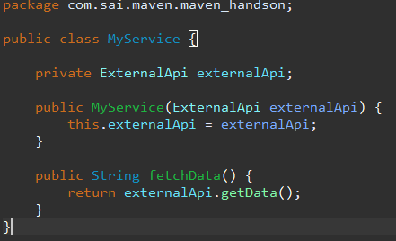

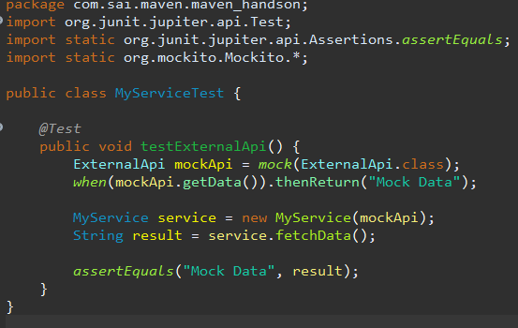

**OUTPUT**:

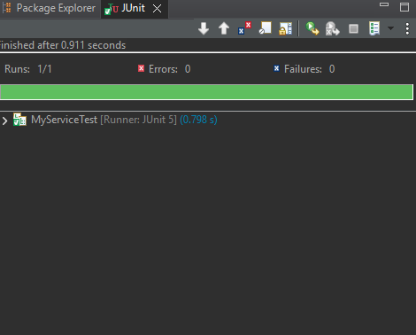

**Exercise 2: Verifying Interactions**

**Scenario:** You need to ensure that a method is called with specific arguments.

**CODE**:

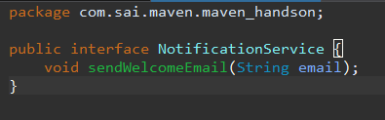

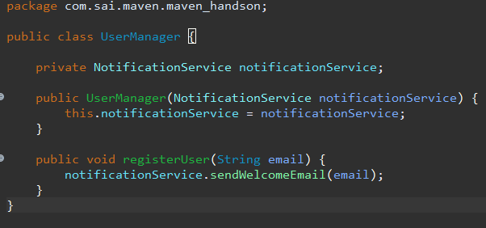

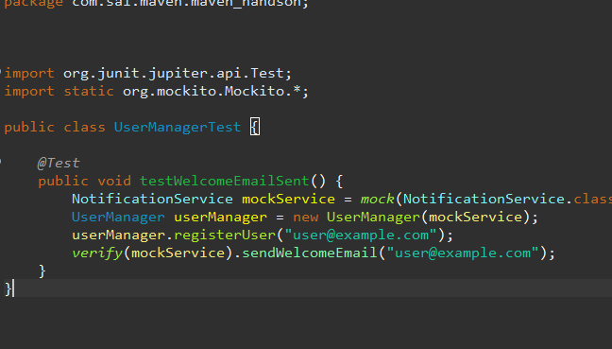

**OUTPUT**:

